Readme File for Wounds and Pathologies

Date: 26 September 2005 (updated 3 July 2006 and 24 Sep 2009)

Summary: The Wounds and Pathologies dataset records data documenting field observations of wounds and pathologies as well as notes on the animal’s subsequent condition or recovery related to the wound/pathology. For entry, data from wounds/pathology field notes are separated into 4 related tables:

- Index Table – Provides basic summary information about the wound/pathology. One row corresponds to every wound/pathology datasheet.

- Wound/pathology Code Table – Lists specific wound and pathologies associated with a row in the index table; provides additional specifics. One row corresponds to every wound and/or pathology code associated with a row in the index table.

- Body Parts Table – Lists the specific body part(s) affected by the wound/pathology. One row corresponds to every body part associated with a row in the index table.

- Healing Rate Table – Documents the healing status and dates for each wound/pathology listed in the index table. One row corresponds to every date of a follow-up comment.

From 20 May Tabby email on in-progress databases:

WOUNDS AND PATHOLOGIES - Needs some help in terms of checking the 2006+ entries and making sure the implied locomotion impairment is captured even if the team doesn't specifically check that box on the datasheet.
Once that data are proofed and correct, you can make tables and add the data to Babase_pending. Don't forget that once you make new tables you will need to change the permissions.

/Impairs Locomotion/

A yes or no field for whether or not the wound/pathology impairs the animal’s locomotion. *NOTE:* Entry of a “yes” for impairs locomotion is inferred if the notes field on the datasheets explicitly describes a locomotion problem and/or if “limp, no wound visible” is checked on the wounds/pathologies codes.
Index Table – Columns:

WID
Every wound/pathology is given a code specific to a particular wound/pathology. The original observation and subsequent follow-up entries should all reference the same code. WIDs are automatically generated.

Date
The date of the initial observation. Dates are in British format (day/month/year).

Time
Time refers to the time that the initial observation was made. Time is recorded in military format.

Observer
The observer column lists the initials of the individual(s) responsible for the observation. Separate multiple observers by slashes.

Sname
Sname is the sname of the baboon with the wound/pathology.

Group
Group is the group ID of the group that the individual was in at the time of the wound/pathology.

Wound/Pathology
The wound/pathology column refers to whether the wound/pathology row refers to a wound, a pathology, or both. Possible code values are:

Wound/Pathology Index
A | Wound
B | Pathology
C | Wound and Pathology

Comments
The comments field is for any comments describing the initial observation of a wound/pathology.

Healing Rate Table – Columns:

WID
This column links the healing rate information back to the Index Table.

Date
The date of the follow-up observation(s). Dates are in British format (day/month/year).

Healing Status
The codes for healing status reflect how the wound/pathology has healed on each follow-up observation date. Possible code values are:

Healing Status Codes
1 | Not healed
2 | Partially healed
3 | Healed
4 | Terminal
5 | Animal missing

NOTE: If a WID refers to more than one wound and they heal at different rates, the healing status codes should reflect the slowest wound(s) to heal.
Body Parts Table – Columns:

WID
This column links the body part information back to the Index Table.

Body Part
Body part locates where the wound or pathology is on the baboon. Not all wounds/pathologies are associated with a body part. Possible code values (in reference to baboon drawing) are:

Body Part Code
0 | Head (unspecified)
1 | Top of head
2 | Eye region
3 | Muzzle
4 | Lower jaw, mouth, throat
5 | Cheek
6 | Ear
7 | Back of head, bald, sides of neck
10 | Arm (unspecified)
11 | Shoulder, armpit
12 | Upper arm, elbow
13 | Forearm
14 | Hand, wrist
20 | Trunk (unspecified)
21 | Ventrum, chest, between legs
22 | Flank
23 | Upper, mid back
24 | Lower back
25 | Sacral region
26 | Hindquarters, PCS
27 | Sex skins
28 | Genitals
30 | Leg (unspecified)
31 | Thigh, knee
32 | Lower leg
33 | Foot, ankle
40 | Tail (unspecified)
41 | Proximal Tail
42 | Tail hook
43 | Distal Tail
44 | Over entire body

Body Part Side
Body part side indicates whether the body part affected was on the left (L), right (R), or center (C) of the animal.

Wound/Pathology Table – Columns:

WID
This column links the body part information back to the Index Table.

Wounds/Pathology Code
The wounds/pathology code refers to the specific code(s) listed on the datasheet. Possible code values are:

Wounds/Pathologies Codes
Wound | 1 | Linear cut or slash
Wound | 2 | Puncture
Wound | 3 | Scrape, amorphous wound
Wound | 4 | Bruise, swelling
Wound | 5 | Multiple small cuts (all < 1 cm)
Wound | 6 | Other wound
Wound | 16 | Unknown/ indiscernible wound type
Wound | 17 | Scalping/ large, open wound on head exposing the skull
Wound | 18 | Broken bone
Pathology | 7 | Limp, no wound visible
Pathology | 8 | Respiration problems, coughing, sneezing
Pathology | 9 | Digestive problems, vomiting, diarrhea
Pathology | 10 | Malaise, weakness, stiffness in absence of wound
Pathology | 11 | Thinning fur
Pathology | 12 | Nosebleed
Pathology | 13 | Discharge, sores
Pathology | 14 | Other pathology
Pathology | 15 | White fur

Maximum Dimension (cm)
The maximum dimension of the wound (in centimeters).

Impairs Locomotion
A yes or no field for whether or not the wound/pathology impairs the animal’s locomotion. NOTE: Entry of a “yes” for impairs locomotion is inferred if notes field on datasheets explicitly describes a locomotion problem and/or if “limp, no wound visible” is checked on the wounds/pathologies codes.

Sign of Infection
A yes or no field for whether or not signs of infection (oozing, redness, or stiffness) were observed. NOTE: Entry of a “yes” for sign of infection is inferred if notes field on datasheets explicitly describes an infection associated with a wound. Note also that this field is for signs of infection at any point during the monitoring of a wound – it is not limited to wound status on first observation.

Data Entry Tips and Tricks

Overview. Entering the Wounds and Pathology data may sound complicated, but it really isn’t bad once you get the hang of it. The most important thing to remember is keeping track of adding all the information to all the possible tables – if you stop for a break, try to avoid leaving entries half-finished. And save the spreadsheet often – nothing is more frustrating than having to enter the same information twice!

Before you even open the spreadsheet and consider starting data entry, take a look at one of the Wounds and Pathology data sheets. A sample one is scanned in below. Familiarize yourself with the type of information collected and what constitutes a new form. You should notice that each datasheet is specific to one animal, but not necessarily a single wound or pathology. For example, in the sample below, on 19 August 2004, Orion was observed with both a wound (scrape, amorphous wound) and a pathology (limp, no wound visible). All follow-ups after the initial description of a wound/pathology are written towards the bottom of the data sheet. Keep in mind that the number of follow-ups and descriptions associated with each follow-up varies somewhat. In the example below, there were two follow-ups to the wounds/pathologies originally recorded for Orion on 19 August 2004 – one follow-up on 28 August 2004 and another on 28 September 2004. In theory, follow-ups should continue until the wound/pathology is healed or the animal dies.

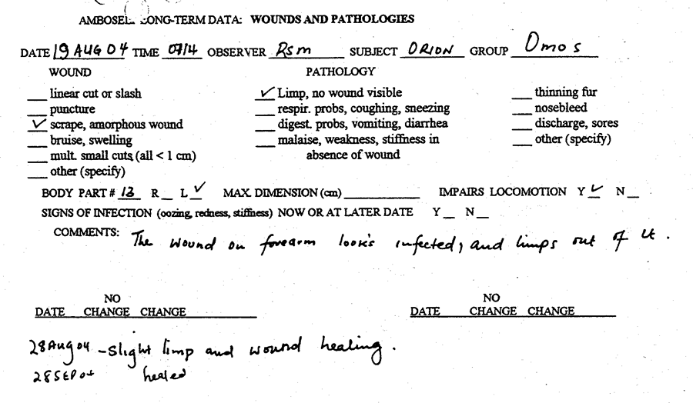

Data Entry. In the paragraphs and tables which follow, I’ll refer to the two sample wound/pathology for Hasty and Nafuu (scanned below) and describe how the data get entered into the various spreadsheets. Before reading on, be sure to look at the written description of the Wounds and Pathologies datasheet for specifics on spreadsheets, columns, codes, etc.

Scanned sample wounds/pathologies:

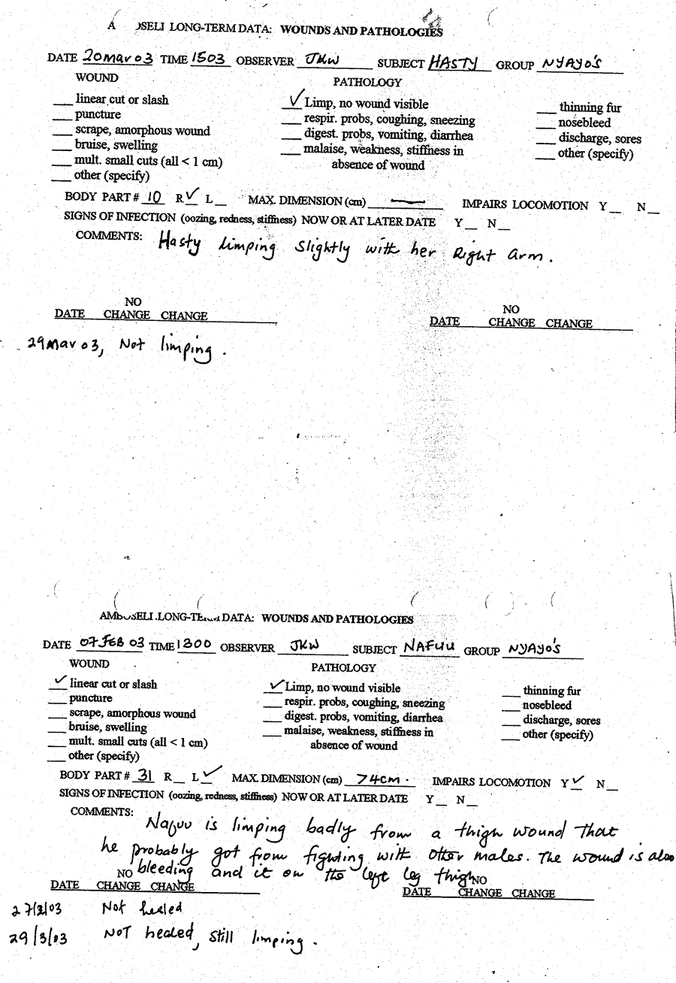

Index Table:

WID | Date | Time | Observer | Sname | Group | Wound/Pathology | Comments
1 | 20-Mar-03 | 15:03 | JKW | HAS | 1.10 | B | Hasty limping slightly with her right arm
2 | 7-Feb-03 | 13:00 | JKW | NAF | 1.10 | C | Nafuu is limping badly from a thigh wound that he probably got from fighting with other males. The wound is also bleeding and it is on the left leg thigh.

- Be certain that you are assigning a UNIQUE WID – otherwise we won’t be able to accurately reference different data tables. If you make a mistake and need to delete a WID, that’s ok but do not worry about filling in gaps. It is ok if WIDs skip a number.
- Remember that the date is in British format.
- Enter the time in military format with a colon.

Healing Rate Table:

WID | Date | Healing Status
1 | 29-Mar-03 | 3
2 | 27-Feb-03 | 1
2 | 29-Mar-03 | 1

- Again, remember that the date is in British format.
- On this and all subsequent tables, check and recheck that you are keeping the WID consistent!
- If there were never any follow-ups made on a wound/pathology, you do not need to enter any rows in this table.

Body Parts Table:

WID | Body Part | Body Part Side
1 | 10 | R
2 | 31 | L

- If no body part applies to the injury (for example, general weakness), then don’t add any data to this table.
- If more than one body part applies to an injury, put each body part in a separate row
- If a wound occurs on both the left and right side of the body, enter two separate rows for “R” and “L” respectively

Wounds and Pathologies Table:

WID | Wound or Pathology Code | Maximum Dimension (cm) | Impairs Locomotion | Sign of Infection
1 | 7
2 | 1 | 4 | Y
2 | 7 |  | Y

- It is not unusual for a single datasheet to reference several wounds/pathologies. That’s no problem – simply create a row for each unique wound or pathology code.
  - In these cases, it may be difficult to determine which wound/pathology the listed wound dimensions, impairs locomotion, and sign of infection notes apply to. The written comments often provide key clues in determining this. Also, feel free to ask Jeanne or Catherine for help.

Additional Notes. Below is text written by L. Okpala on some additional data entry rules.

- When body part fell off/out (i.e., canine, eye) entry marked as healed and note was made of it

- Wound/pathology deemed as permanent was said to be “healed”

- If wound had been reopened and a separate record sheet was NOT made for it then the wound was marked as partially healed (2) and a note was made that another new injury existed

- If a separate data sheet was made for the reopened wound, then the wound was treated as a new wound and an entirely separate entry was made

- If wound not classified as reopened but two separate data sheets were made at the same time but for different wounds, both the data sheets were combined, and a note made in the data book

- If infection and impairment of locomotion could be inferred from the data sheets it was checked off and marked on the data sheet

- If limping was checked on data sheet but comments inferred that limping was caused by wound, then the checked off “limping, no wound visible” was disregarded and “impairs locomotion” was checked off

- Distinction between partially healed, healed and not healed was inferred from the notes. If “healed” put down twice for separate dates then each date got a separate entry

- If limping from wound is noted after initial injury, then check “yes” in the impair locomotion category

- Sometimes data sheet will say “limp or stiffness from wound” rather than “limp, no wound visible”. Take note of this and if “limp from wound” is checked off, then disregard this and check off “impairs locomotion” in addition to noting the original wound.

- All instances of fur abnormalities are included under the “thinning fur” (11) category. This includes, but is not limited to, notes citing things such as “a rough coat,” “a bare patch of fur,” and/or a region of the body missing fur.

MATERNAL GROUP CODES

1.0 | Alto’s | 2.0 | Hook’s | 3.0 | Lodge
1.1 | Nyayo’s | 2.1 | Linda’s | 3.1 | Joy
1.2 | Dotty’s | 2.2 | Weaver’s | 3.2 | Nzigi
1.3 | Proton’s |  |  | 9.0 | Unknown
1.21 | Omo’s
1.22 | Viva’s (or Viola’s)

