Ranker 2.0 Web-application
  - User Manual

Portal Home Page
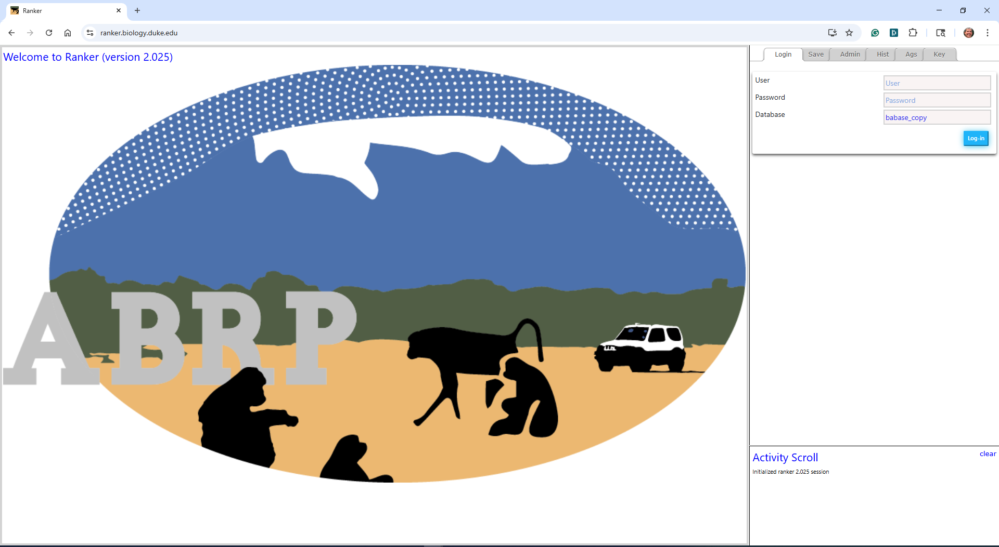
Figure 1- Ranker 2.0 Portal Home Page
The Ranker 2.0 application, as seen on the portal, is divided into three areas. The primary area, the large area to the left is for viewing and editing ranking grids. The right panel of the portal is divided into a data entry and viewing area on top with six tabs, and a scrolling activity log at the bottom of the panel.

Login Tab
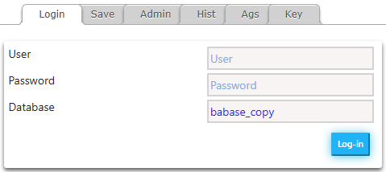
Figure 2- Login Tab
The Login tab has three data entry fields and a Log-in button. A valid user, password and database will authenticate you to the Babase data store. You will be able to review ranking profiles for groups of baboons. If you have write privileges you will also be able to save edits to the data store. The button will change to a 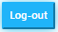 button after you log in.

Admin Tab
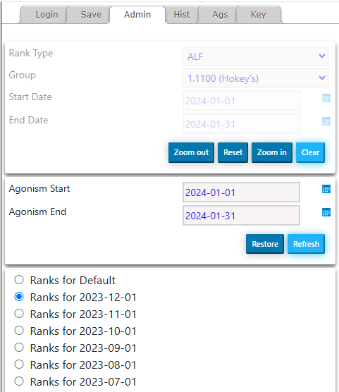
Figure 3- Admin Tab
The Admin tab has basic ranking group selection fields as well as custom agonism date range selection fields and ranking basis radio buttons. You may click on the calendar tool to help select dates. The calendar will default to the most recent date for a saved ranking.
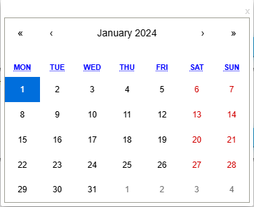
Figure 4- Calendar Tool
Select the date you want using the tool. You may use the broad date range row at the top to adjust the year and month and pick the date in the calendar below. Double click on a date to accept the date and close the calendar. You may also close the calendar by clicking on the “x” at the top right of the tool or by clicking anywhere off of the Calendar tool. Note that when you select a start date, if the end date field is empty it will be pre-filled with the last day of the start date month.
Also, there are buttons for managing the size of the ranking grid. A rank type, group, start-date and end-date will define a ranking grid to review and edit in the workspace to the left. The 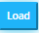 button will prepare the workspace. When the workspace is prepared, the agonism date range will default to the start and end date for the workspace. The ranking basis will default to the ranking for the current selection if it has been saved or for the last saved ranking basis for the rank type and group. If no such basis exists, the ranking basis will conform to a default ranking basis which uses an algorithm based on gender and age. A button will replace the load button when you load the grid and may be used to clear it.
Note: when a large grid is selected you will want to use the button to fit the grid to the workspace. You may use the button to restore the grid to the default size or the 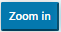 button to enlarge the grid.

The button will reload agonisms on the grid for the date range defined in the agonism range fields. The button will reload the default agonism range.

You may use the radio buttons 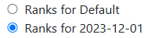to change the ranking basis.

The Ranking Grid
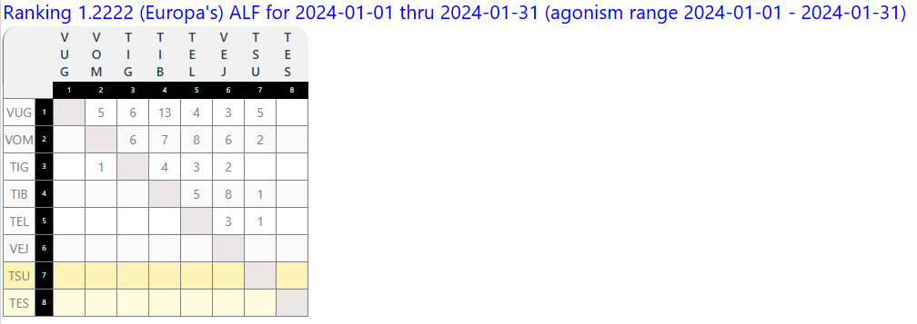
Figure 5- Ranking Grid
The Ranking grid has four features that you may use to assist you in ranking individuals: rollover biographies, color-coded individual status, highlighting of individual vectors and drag-and-drop ranking updates. Additionally, there are two tabs in the side panel that will augment your work: History and Agonisms. One additional feature of the Ranking grid is a readout of the ranking group, ranking type, start date, end date and displayed agonism range. In the example above you will observe: Ranking 1.2222 (Europa’s) ALF for 2024-01-01 thru 2024-01-31 (agonism range 2024-01-01 – 2024-01-31).
Rollover Biographies
You may see a number of properties for an individual by rolling over the individual’s “sname” either on the left column or the top row header.
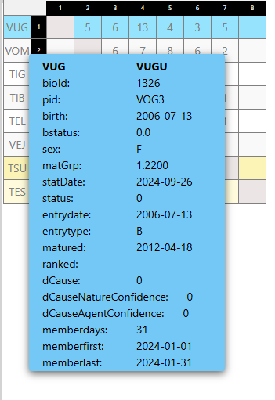
Figure 6 - Rollover Biography
Color Coding
Individual status is color-coded for Juveniles, Newborns and Immigrants. There is a tab with a Color Key indicating the color-coding.
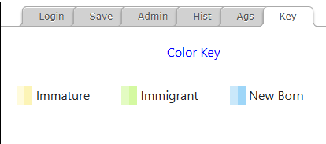
Figure 7- Color Key Tab
Yellow – Juveniles (immature for females, unranked for males)
Blue – Newborn (born in the ranking month)
Green – Immigrant (was not in the group during the previous month, and is not a newborn)

Vector Highlighting
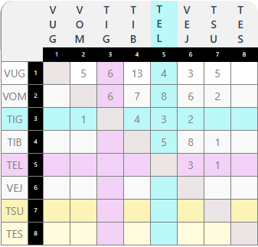
Figure 8- Agonism Vector Highlighting
You may click on an agonism in the grid to highlight extended vectors for the winner and loser in the agonism. This will aide you in reviewing agonisms between the two parties and other individuals in the group. A blue highlight shows vectors where the winner has prevailed and the loser has yielded. A purple highlight shows vectors where the winner has yielded and the loser has prevailed. Note: a history of agonisms between the two parties will appear in the agonism tab in the right panel.
Clicking the same cell again will remove the highlighting.
You may also rollover an agonism score to see a small pop-up readout of the “snames” for the two parties in the agonisms. The readout shows <winner> x <loser> where x is the number of times the winning party has prevailed. For example: 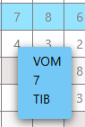
Drag-and-Drop Ranking
Anywhere on a row, if you click the mouse down and hold it down, you may drag an individual up to give them a higher rank or down to give them a lower rank. You may continue to edit the grid including reverting rank changes using the history table tab in the right panel. When you have completed editing the grid, you may save the ranking by using the save tab in the right panel.

History Tab
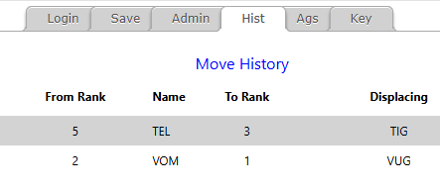
Figure 9- History Tab
The History tab displays edits to the ranks in the ranking grid. The most recent change is at the top. Each row shows the original rank for the “sname” of the re-ranked individual. The new rank is displayed and the “sname” for the displaced individual previously holding the rank is also displayed. Displaced individuals are demoted to the rank directly below the rank they originally held. Note, history changes are also reflected in the activity log at the bottom of the utility panel.
Click a rank in the grid to undo edits to the rankings. This will revert/restore ranks to the ranks before the edit. Clicking the top row will revert the last edit. Clicking a row lower down will “unwind” edits, restoring each row until the clicked row is reverted. Reverted rows are removed from the edit history.

Agonism Panel
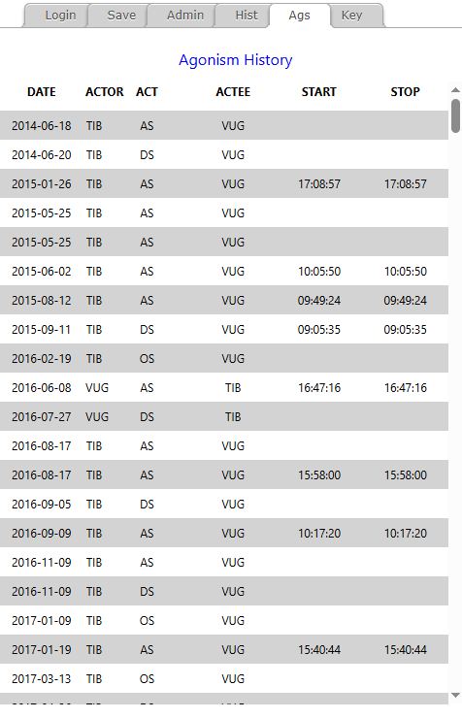
Figure 10 - Agonism Panel
When you use Vector Highlighting to highlight agonism vectors for individuals the utility panel at the right will display an agonism history for the two individuals involved. This panel is a readout of the agonism history with the oldest encounter at the top.

Save Panel
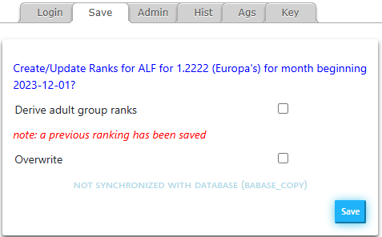
Figure 11 - Save Panel
The save panel will store an edited ranking to the RANKS table in the database you provided at login. You must have permission to save a ranking. If you are not permitted to save rankings you will see a notification in the scrolling Activity panel at the bottom of the utility panel.
The save panel includes a summary of the ranking parameters: rank group, rank type, start-date and end-date. You may only save a ranking that begins on the first day of a month and ends on the last day of the same month.
Additional features are: check-box to derive adult group ranks, a warning that a ranking has already been saved for the defined ranking, a check-box to override a previously saved ranking and a notice indicating that the current ranking is not synchronized with the database. The save button will only appear enabled when the current ranking is not synchronized.
Derive Adult Group Ranks
When you save a ranking for all females or all males, you may elect to also save the same ranks for the associated group of only adult individuals (mature females or ranked males). You may effect this by checking the “derive” box. When the box is checked, a new or updated derived ranking will be saved when the save button is clicked with no further warning.
Overwrite
A warning message will appear if there is a previously saved ranking for the ranking set you have defined. If you check the “overwrite” box, the edited ranking will replace the currently saved ranking with no further warning.

Activity Scroll
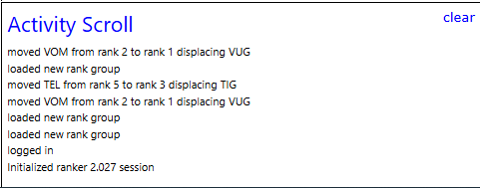
Figure 12 - Activity Scroll
The Activity Scroll will display a rolling notification of actions you take during your ranking session. The most recent action will appear at the top. Warnings and errors will appear in red 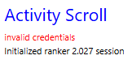such as this “Invalid credentials” message.
You may clear the history in the Activity Scroll by clicking the link at the top left of the Activity Scroll.

