Babase Wiki Sharing
https://papio.biology.duke.edu/babasewiki/

“A collaborative hypertext environment, with an emphasis on easy access to and modification of information,” is the best way to describe a Wiki. Babase has its own wiki. Our Wiki allows the sharing of SQL queries and helpful tips and tricks on using Babase. What makes this such an interactive type of “tips and tricks” website, is that anyone who is a BabaseWikiEditor can add to and modify the site as is quoted above. Therefore, as we move to using strictly Babase for data management, everyone can readily share their experiences with in order to expedite the learning process for everyone who is learning the ins and outs of this complex database. There is also a place on the Wiki to list quirks, grievances, and of course, LOVE for the database. Karl does his best to attend to this list and, as priority allows, make changes to the database in accordance with these comments. Babase is going to be continually evolving, and the wiki allows everyone to be a contributor to that evolution.

- In order to use the BabaseWiki to share code, protocols, etc. you must first create a Wiki Login and Password on the “Login” Page
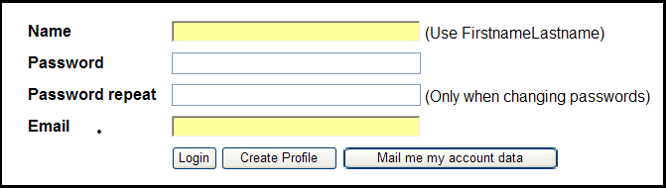

- If you plan to use the Wiki to share information, you will need to be added as a BabaseWikiEditor by one of the BabaseWikiAdmins.
  - Karl, Jeanne, Susan, Tabby, and Lacey.
- To add new pages:
  - Edit(Text) on “MyStartingPage”

  - Add new Header (if applicable)
  - Add new page link under Header (save changes with comments)
  - Edit new page (by clicking on link from “MyStartingPage”)
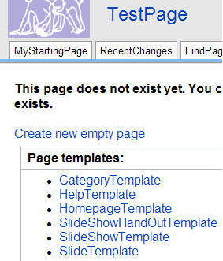

- Sharing Documents, Files, etc
  - Share as an Attachment
    - After adding a brief description of new page using text editor, use attachment link on the new page to upload desired files.

  - Share as Interactive Wiki Document
    - Copy/Paste Existing Document into the Text Editor of the newly created page
    - Use code to create an interactive Wiki page
      - Eg: SQL Language for Babase page
- Commonly Used Code For Interactive, or in-text Wiki Documents:
  - [[TableOfContents]]
  - Headings: = Title 1 =; == Title 2 ==; === Title 3 ===; ==== Title 4 ====; ===== Title 5 =====
  - Emphasis: ''italics''; '''bold'''; '''''bold italics'''''; ''mixed '''bold''' and italics''; ---- horizontal rule
  - Links: JoinCapitalizedWords ; or [:PageName:Page Name]
  - Tables: ||Date||||Actor||
||Jan 25||||VIN||
  - Bullets: * Text for Bullet (space*spaceText)

